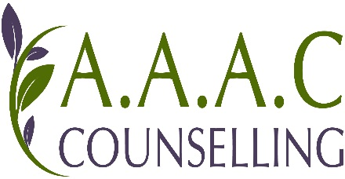

Looking After your Information

When you attend AAAC Counselling we
We care about your information:

- We only collect what we need and nothing else

- We make sure it is correct

- We keep it private

- We keep it for 5 years

Keep some information about you

For Example:

Your name, your age and what
You are worried about

This is because we want to make
sure, we give you the best support,
and so, we can count how many
people work with AAAC and if it enables them to have a positive life changing experience

You can ask us what information we keep about you

If you have any questions about this just ask your AAAC Counsellor

